What Does a Mobile App Developer Do in Dubai?
Focus Keyword: Mobile App Developer Dubai
Meta Title: What Does a Mobile App Developer Do in Dubai?
Meta Description: Discover what a mobile app developer in Dubai does, from designing and coding apps to testing and delivering seamless user experiences.
Feature image:

Introduction
Dubai continues to grow as a global technology hub. A Mobile App Developer Dubai supports many industries through smart and user friendly applications. Dubai offers strong opportunities in both corporate and freelance sectors. Developers handle design work, coding tasks, testing stages, and final deployment. They support teams by guiding technical decisions. They also maintain apps after launch to ensure smooth performance. Their work shapes daily digital interactions across Dubai. Many professionals, including Mistersaad, rely on skilled professionals to deliver quality digital products. Developers combine creativity with technical skill to meet client goals. Their role grows each year with rising demand for mobile services. This article explains how developers work and what they handle daily. The sections provide clear insights into their responsibilities across Dubai’s tech landscape.

Understanding the Core Role of App Developers
App developers create mobile applications for different user needs. Their work involves planning features and understanding client goals. They collaborate with designers and project teams to prepare app structures. They write clean and efficient code for each function. They test each feature to ensure strong performance. Developers also fix issues before the app reaches users. Their work improves business reach and service quality. They stay updated with modern tools and programming trends. They handle research to support better app ideas. Their role requires focus and consistent learning. Every project strengthens their skills. Their value remains high in Dubai’s digital market.

Roles and Responsibilities in Dubai’s Tech Market
A developer manages many project tasks each day. They study requirements to understand the complete vision. They build functions that match business goals. They secure user data through safe coding methods. They attend team meetings to share updates on progress. They create technical documents for future reference. They support deployment work to ensure smooth app launches. They monitor app performance after release. They handle bug reports from users or clients. They guide clients through app features. They improve old apps with modern updates. Their work helps companies achieve strong digital growth. Their responsibilities shape final project success.

Industry Insights for Developers
Dubai offers a strong market for mobile applications. Many companies need developers to build secure and user friendly tools. Developers often support digital growth in retail and services. They also help finance firms with advanced applications. They work on apps for travel, food, education, and fitness sectors. The market continues to expand each year. Developers benefit from stable demand and better salaries. They find many opportunities to work on creative projects. Dubai’s modern infrastructure supports strong tech development. Developers gain exposure to global tools and new frameworks. The city remains a leading destination for tech careers.


Roles and Responsibilities of App Developers
A developer studies app goals with careful detail. They choose the correct tools for each project. They plan the structure to support strong performance. A Roles and responsibilities of app developers list includes coding, testing, and deployment. They solve complex problems using clear logic. They support designers by connecting features with code. They protect user data through secure methods. They update apps with new features over time. They review client feedback to improve the experience. Their work remains essential to digital progress. They support Dubai businesses through powerful apps. Their responsibilities build trust and long term growth.

Freelance App Developer Dubai Job Structure
A Freelance app developer Dubai job includes many tasks that require careful planning. Freelancers study client needs with close attention. They propose clear timelines for each feature. They build apps that match brand identity. They prepare design samples for client review. They handle coding tasks across different platforms. Freelancers test functions before handing over the product. They fix issues found during testing. They help clients publish apps on stores. They support all updates after launch. They manage their own invoices and work plans. Dubai offers steady freelance opportunities. The job supports flexible and creative work styles.

Skills of Mobile App Developers
A Skills of mobile app developers list includes problem solving and logical thinking. They understand coding languages used in app development. They know how to work with databases. They work well with designers and product teams. They understand user experience rules. They stay updated with new tools and platforms. They write clean and readable code. They test functions with careful detail. They manage time to meet deadlines. They support clients with clear communication. They understand app store rules. These skills help them deliver strong digital solutions. Dubai values skilled professionals with these abilities.

iOS and Android Development in Dubai
An iOS and Android developer Dubai creates apps for both major platforms. They understand differences between the systems. They follow interface rules for each device type. They write code using specific languages for both platforms. They test apps on real devices. They fix errors for smooth performance. They guide clients on platform best practices. They update apps with new features. They check store guidelines before submission. They manage feedback after launch. Their work supports strong digital presence for many brands. Dubai offers high demand for cross platform developers. Their skills remain important for business success.
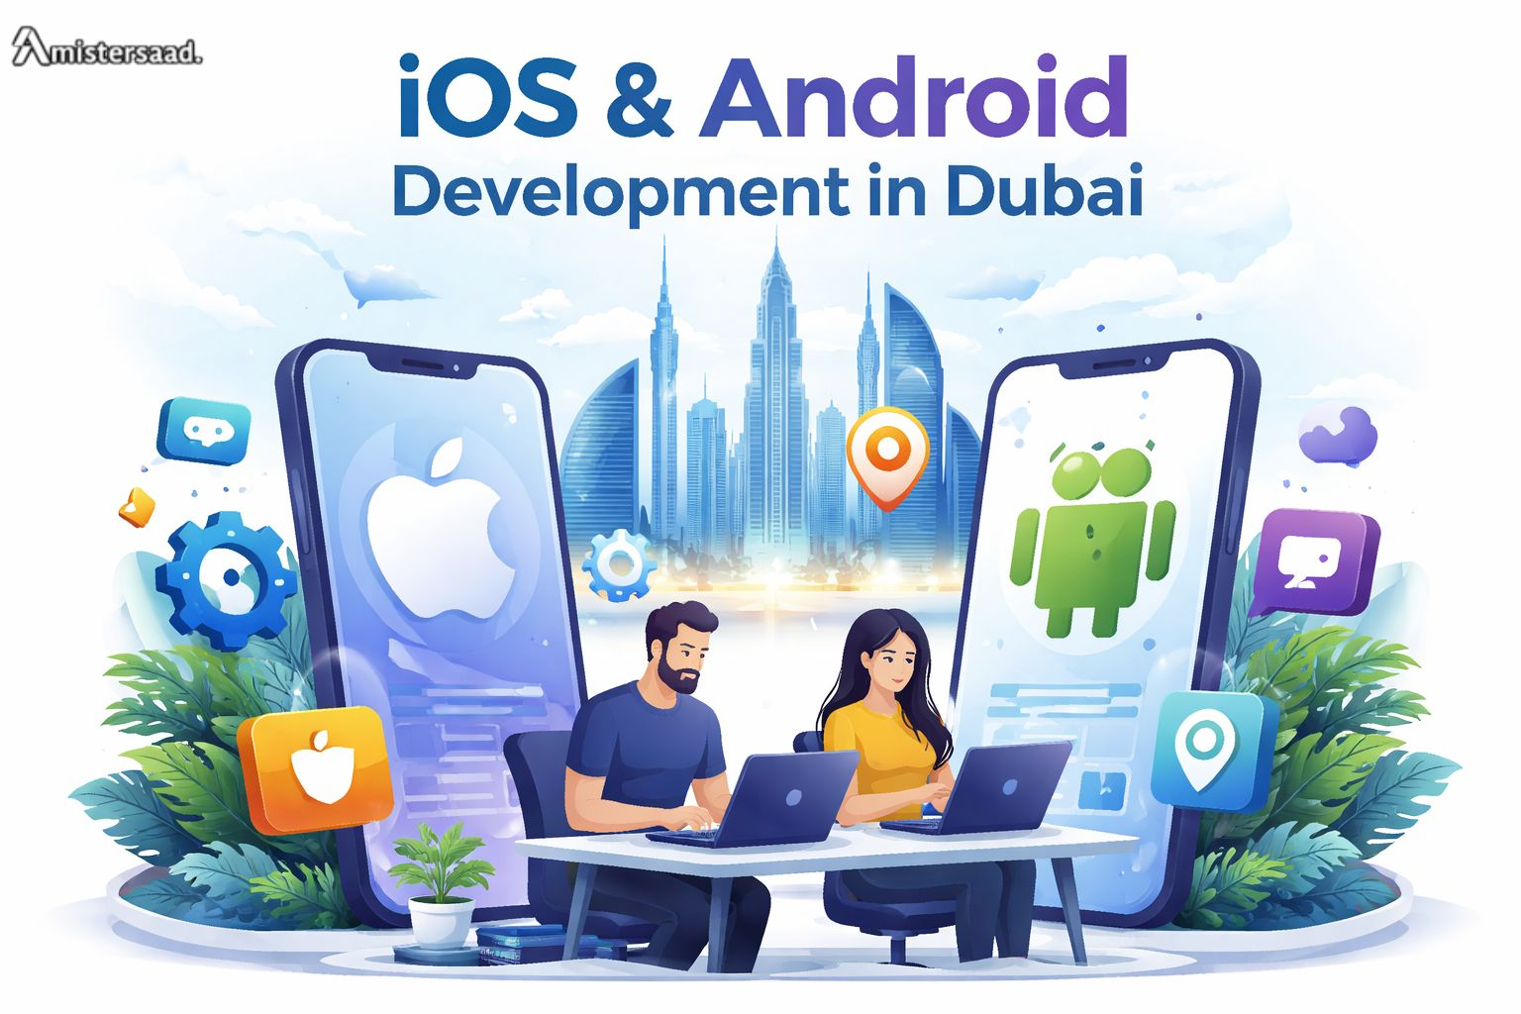

App Design and Coding Process Explained
The App design and coding process starts with clear planning. Developers study user needs before writing code. They prepare wireframes to show layout ideas. They work with designers to finalize screens. They build each feature using efficient code. They test each part during development. They fix errors quickly. They link all screens for smooth flow. They prepare the app for final testing. They follow best practices to secure user data. They optimize performance for speed. They submit apps to stores after review. The process ensures quality results. Dubai businesses trust this workflow for reliable apps.


Dubai IT Professionals in the Mobile Sector
A Dubai IT professionals group includes many skilled developers. They support companies with modern digital solutions. They work on creative and high value apps. They follow global coding standards. They use advanced tools for better results. They support clients across many industries. Their work helps Dubai maintain its strong tech reputation. They focus on innovation and reliability. They collaborate with local and international teams. They guide companies through digital projects. Their skills remain essential for the city’s growth. Many developers choose Dubai for stable careers. The tech sector continues to expand each year.

App Developer Daily Tasks
An App developer daily tasks list includes coding and testing. They check project updates each morning. They review feedback from clients. They write new functions for ongoing projects. They fix errors found during tests. They attend team meetings to share progress. They check app performance across devices. They update documentation for future use. They plan tasks for the next day. They assist designers with technical details. Each task supports the final product. Their daily work shapes app quality. Developers follow structured routines for strong results. Their workflow ensures stable and efficient applications.

How Dubai Supports the App Development Field
Dubai offers strong support for developers. The city provides modern tech spaces for companies. Developers access advanced hardware and software. They attend training and events to improve skills. Many firms hire developers for long term roles. Dubai’s business environment encourages digital innovation. Investors support new app ideas. Companies build strong digital teams. Many developers join global projects in Dubai. The city’s stability attracts skilled professionals. Tech communities offer guidance and learning opportunities. Developers feel encouraged to grow in this environment. The support helps developers deliver better applications.

Career Growth in App Development
App developers find many growth paths in Dubai. They start with small projects to build experience. They move into senior roles with time. They manage teams with strong leadership. They guide new developers in large projects. They work on advanced tools as their skills grow. They join creative departments for design tasks. They grow into project managers. They work with global clients across Dubai. They gain exposure to many industries. Their growth depends on skill and dedication. Dubai rewards professional improvement. Developers enjoy stable and growing career options.

Conclusion
Dubai offers strong opportunities for app developers across many sectors. Skilled professionals handle design, coding, testing, and updates. Companies need developers to support digital growth. A Freelance Mobile App Developer Dubai and full time professionals both find steady demand. Dubai’s digital market grows each year through new ideas. Businesses rely on developers to create smooth and effective applications. Developers support clients with technical knowledge and creative ideas. Their work shapes digital experiences across the city. They play a major role in Dubai’s technology progress. Their skills remain essential for modern businesses. The city continues to attract talent for its expanding digital needs.

FAQs
1. What skills help developers succeed in Dubai?
Strong coding, testing, and communication skills help developers grow.
2. Do developers work on both Android and iOS?
Many developers handle both platforms with cross platform tools.
3. Is freelance app development common in Dubai?
Yes, many clients prefer flexible and cost friendly freelance services.
4. Do developers handle app updates?
Yes, developers manage updates to improve features and performance.
